
Touchstones Project
Netcards

Equity Netcards with Text

Activism HRJ
All HRJ
Blue Collar HRJ
Bucket HRJ

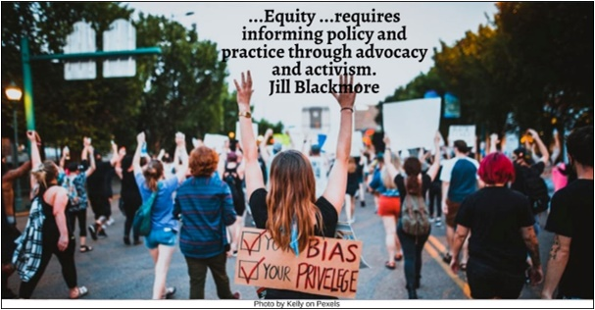

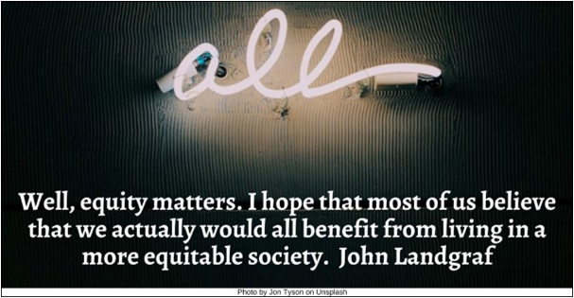

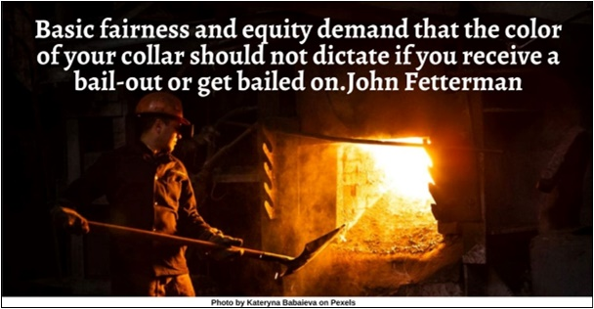

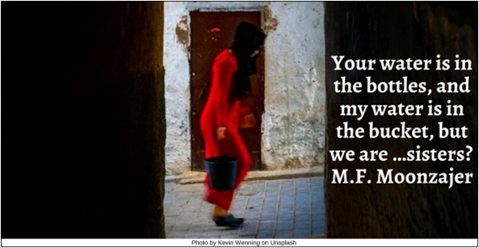

Connected HRJ
Dance HRJ
Desolation HRJ
Do Equity HRJ

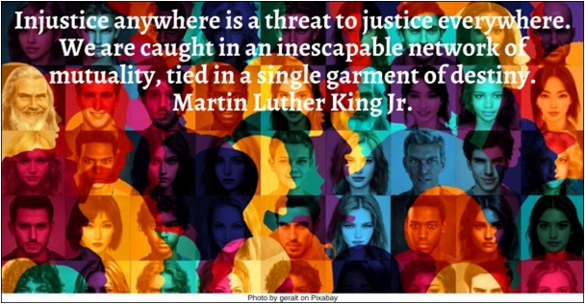

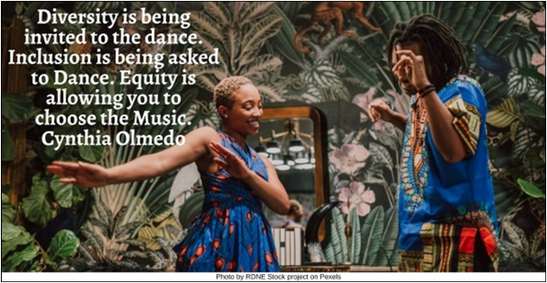

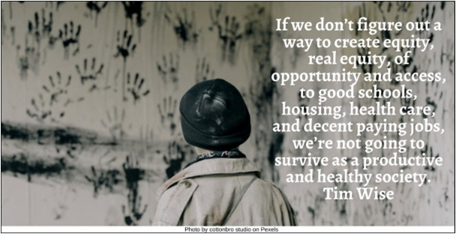

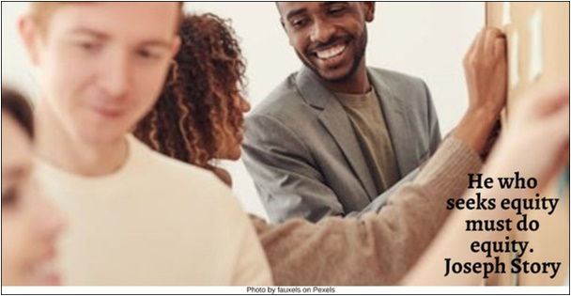

Each Other HRJ
Fair Shot HRJ
Fairness HRJ
Fight HRJ

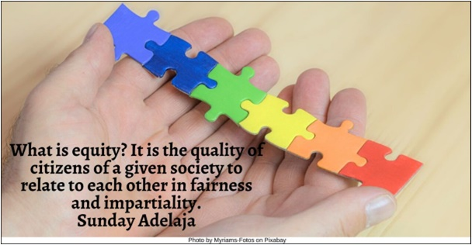

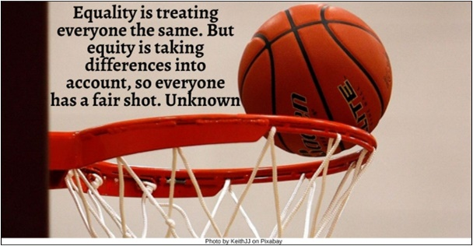

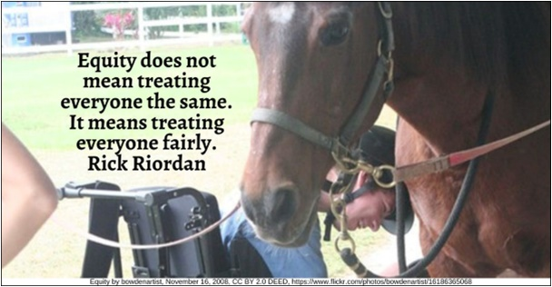

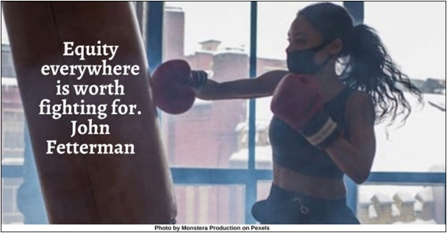

Foundation HRJ
Gender Equity HRJ
Goal HRJ
Injustice HRJ

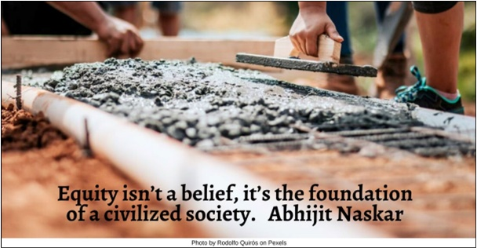

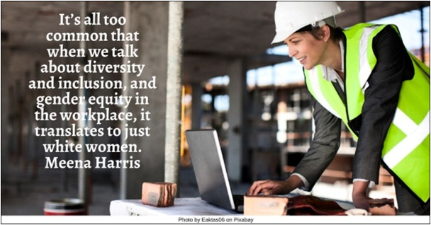

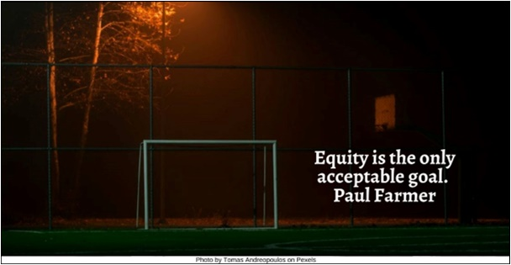

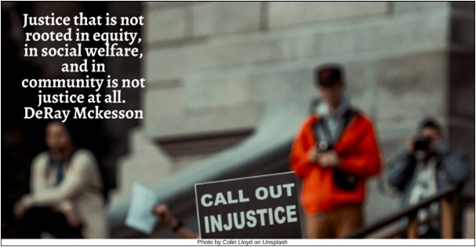

Internet HRJ
Intersects HRJ
Judge HRJ
Law HRJ

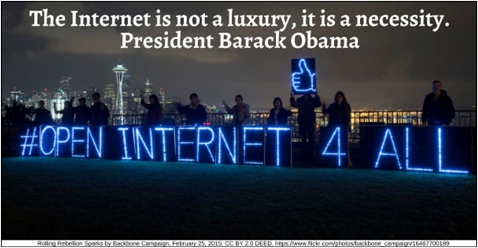

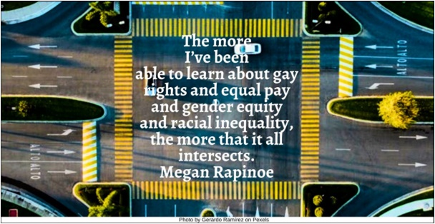

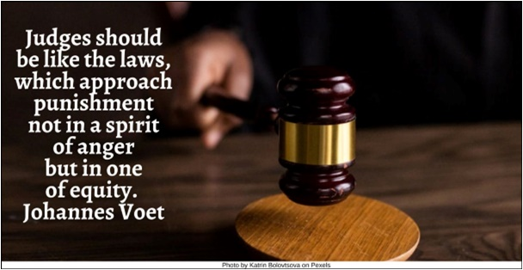

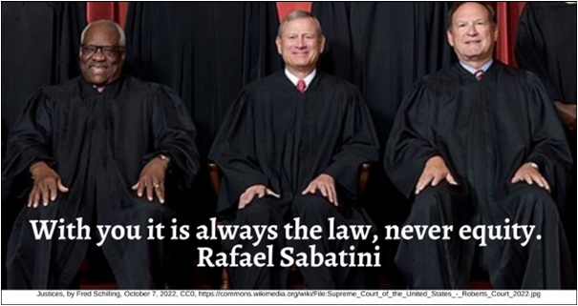

Masquerade HRJ
Michelle Obama HRJ
Path HRJ
Pay Equity HRJ

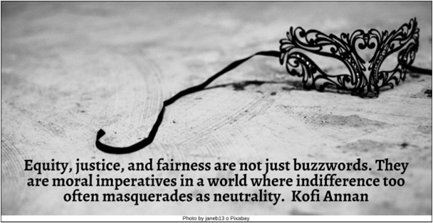

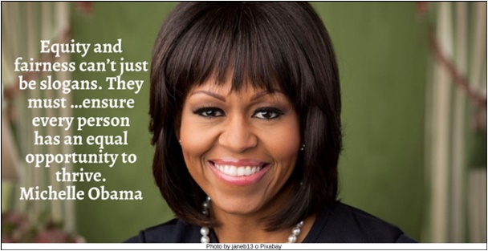

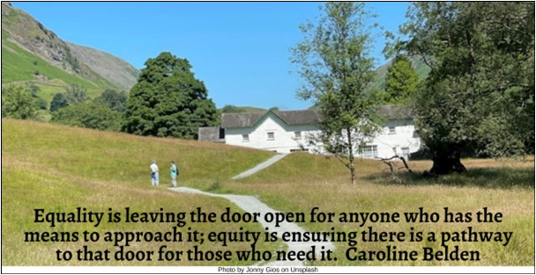

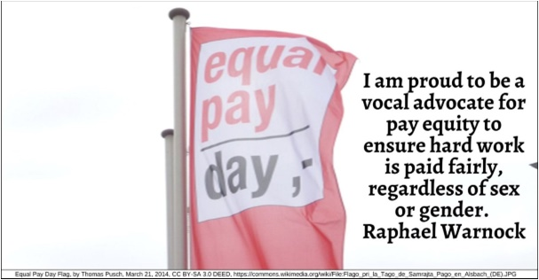

Reading HRJ
Right and Wrong HRJ
Spirit of Justice HRJ
Vote HRJ

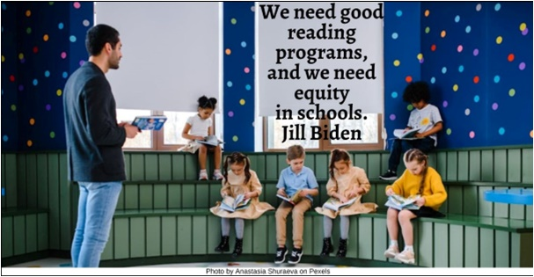

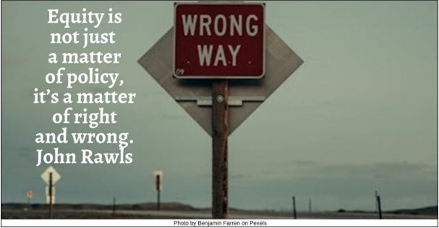

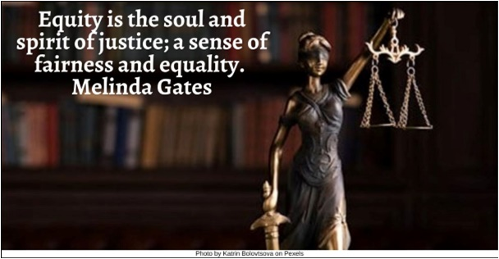

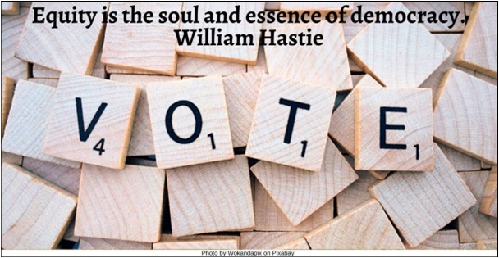

White Privilege HRJ
Yellowstone HRJ
Zero Sum Game HRJ

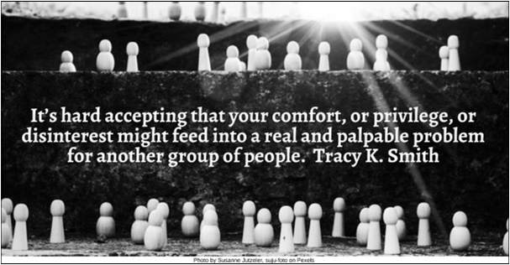

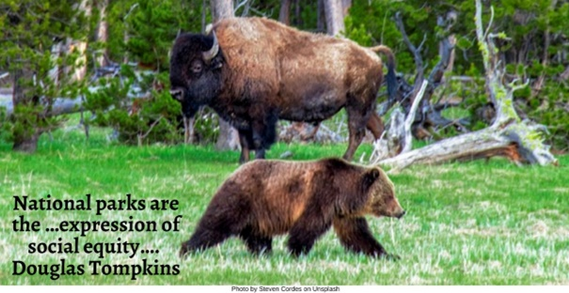

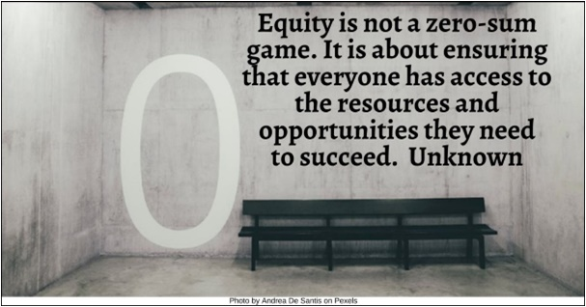

Text of Quotes
Activism HRJ
…Equity …requires informing policy and practice through advocacy and activism. Jill Blackmore

All HRJ
Well, equity matters. I hope that most of us believe that we actually would all benefit from living in a more equitable society. John Landgraf

Blue Collar HRJ
Basic fairness and equity demand that the color of your collar should not dictate if you receive a bail-out or get bailed on. John Fetterman

Bucket HRJ
Your water is in the bottles, and my water is in the bucket, but we are …sisters? M.F. Moonzajer

Connected HRJ
Injustice anywhere is a threat to justice everywhere. We are caught in an inescapable network of mutuality, tied in a single garment of destiny. Martin Luther King Jr.

Dance HRJ
Diversity is being invited to the dance. Inclusion is being asked to Dance. Equity is allowing you to choose the Music. Cynthia Olmedo

Desolation HRJ
If we don’t figure out a way to create equity, real equity, of opportunity and access, to good schools, housing, health care, and decent paying jobs, we’re not going to survive as a productive and healthy society. Tim Wise

Do Equity HRJ
He who seeks equity must do equity. Joseph Story

Each Other HRJ
What is equity? It is the quality of citizens of a given society to relate to each other in fairness and impartiality. Sunday Adelaja

Fair Shot HRJ
Equality is treating everyone the same. But equity is taking differences into account, so everyone has a fair shot. Unknown

Fairness HRJ
Equity does not mean treating everyone the same. It means treating everyone fairly. Rick Riordan

Fight HRJ
Equity everywhere is worth fighting for. John Fetterman

Foundation HRJ
Equity isn’t a belief, it’s the foundation of a civilized society. Abhijit Naskar

Gender Equity HRJ
It’s all too common that when we talk about diversity and inclusion, and gender equity in the workplace, it translates to just white women. Meena Harris

Goal HRJ
Equity is the only acceptable goal. Paul Farmer

Injustice HRJ
Justice that is not rooted in equity, in social welfare, and in community is not justice at all. DeRay Mckesson

Internet HRJ
The Internet is not a luxury, it is a necessity. President Barack Obama

Intersects HRJ
The more I’ve been able to learn about gay rights and equal pay and gender equity and racial inequality, the more that it all intersects. Megan Rapinoe

Judge HRJ
Judges should be like the laws, which approach punishment not in a spirit of anger but in one of equity. Johannes Voet

Law HRJ
With you it is always the law, never equity. Rafael Sabatini

Masquerade HRJ
Equity, justice, and fairness are not just buzzwords. They are moral imperatives in a world where indifference too often masquerades as neutrality. Kofi Annan

Michelle Obama HRJ
Equity and fairness can’t just be slogans. They must …ensure every person has an equal opportunity to thrive. Michelle Obama

Path HRJ
Equality is leaving the door open for anyone who has the means to approach it; equity is ensuring there is a pathway to that door for those who need it. Caroline Belden

Pay Equity HRJ
I am proud to be a vocal advocate for pay equity to ensure hard work is paid fairly, regardless of sex or gender. Raphael Warnock

Reading HRJ
We need good reading programs, and we need equity in schools. Jill Biden

Right and Wrong HRJ
Equity is not just a matter of policy, it’s a matter of right and wrong. John Rawls
Spirit of Justice HRJ
Equity is the soul and spirit of justice; a sense of fairness and equality. Melinda Gates

Vote HRJ
Equity is the soul and essence of democracy. William Hastie

White Privilege HRJ
It’s hard accepting that your comfort, or privilege, or disinterest might feed into a real and palpable problem for another group of people. Tracy K. Smith

Yellowstone HRJ
National parks are the …expression of social equity…. Douglas Tompkins

Zero Sum Game HRJ
Equity is not a zero-sum game. It is about ensuring that everyone has access to the resources and opportunities they need to succeed. Unknown

